Agricultural Erosion Control Structures – Watershed Delineation Project
  - Summer 2026
Current oversight: Sian Bryson, Sarah Gunnewiek
Previous oversight: Anthony Loschiavo, Kevin McKague
For help, please contact me at sbryson18@outlook.com. Future improvements to the documentation can also be found on the project’s GitHub repository.

Contents
Agricultural Erosion Control Structures – Watershed Delineation Project 1
About the product 1
QGIS methodology 2
ArcGIS Workflow 2
imagery.py 3
hydrology.py 3
report.py 3
utils.py 4
Using the web tool 5
Maintaining the web tool 6
Uploading a geoprocessing (GP) tool to ArcGIS Enterprise 6

About the product
The watershed delineation tool is hosted on the Ontario Geohub platform and is intended to be public at a future date. The tool is intended to automate calculations that were done by hand in previous workflows for a more seamless and user-friendly experience. The geoprocessing is also offloaded onto the OGP server, so users’ RAM is not a barrier. Network speed may be a blocker, however.

Previous QGIS methodology
Expands on the methodology established in the AgErosion tool.
Original idea was to automate the workflow in QGIS, since setup, app navigation, and acquiring data is too technically demanding for some users. Upon trying to set up to create an automated model for some of the delineation, I kept running into technically demanding issues. Plugins have to be downloaded from a third-party site and installed by the user, the WCS server has to be accessed for imagery, imagery needs to be saved locally. It may be possible to get around some of this with Python scripting, but that would probably require a user to know how to run Python scripts. (Writing the script would be pushing the envelope on my skills; I do not have any experience with creating GUIs/shells for scripts.)
Idea is to offload as much of the processing onto a server as possible, making these tools more accessible to users that may be limited by their hardware.

ArcGIS Workflow
To make scripts easier to maintain, the toolbox has been broken up into several scripts for different parts of the process. watershed_delin_tools.pyt is the main Geoprocessing Tool script. It interfaces with ArcGIS Pro/Enterprise to pass parameters into the scripts. It references the scripts in the gp_scripts folder, which contains:
- __init__.py: empty but necessary for ArcGIS Pro to recognize the files correctly
- hydrology.py: contains all scripts for performing hydrological analysis on the imagery. Also performs stream length and elevation calculations.
- imagery.py: retrieves a section of clipped imagery from the ArcGIS REST server at a specified resolution
- report.py: packages watershed statistics into an HTML report
- utils.py: boilerplate helper functions used in the other scripts

imagery.py
Retrieves LiDAR imagery from the ArcGIS REST server. The URL to access the image service is hard-coded as image_service, but it could be altered as desired.
An image server layer is created with a resolution of the input cell size. The raster is clipped using ExtractByMask. Gaps between mosaiced tiles in the imagery that sometimes occur are filled by running FocalStatistics to determine the average value of the 8 pixels around each empty pixels.

hydrology.py
Contains the main hydrology functions (hydro_raster_tools and vector_raster_tools), as well as watershed stats calculator functions (best_path, elevation_difference, and get_stream_stats).
hydro_raster_tools
Performs the raster-based parts of the hydrological analysis.
- Fills sinks in the DTM imagery with Fill.
- Calculates Flow Direction and Flow Accumulation
- Creates a stream network from the flow accumulation output.
- Calculates Strahler order for the stream network using Stream Order. These values will be used later in the best_path function.
hydro_vector_tools
Performs the vector-based hydrological processes.
- Snaps the input pour point to the nearest stream segment using Snap Pour Point with a threshold radius of 50 metres. The output snapped point from this function is a raster, so Raster To Point is used.
- Runs the Watershed tool, then converts the output watershed to a polygon using Raster To Polygon.
- Converts the raster stream created in hydro_raster_tools to a Line Feature with Stream To Feature.
best_path
Only executed if the user has chosen to generate the watershed. Grabs the longest stream path in the network. Depending on resolution and stream threshold, this will not always connect to the end of the watershed.
elevation difference
Grabs the coordinates of the start and end points of the best_path line and finds the value in the elevation raster at both coordinates. Subtracts the elevation at the outlet point from the elevation at the headwater.
get_stream_stats
Using an ArcPy search cursor, finds the area of the watershed polygon and the length of the line created by best_path. Formats these values along with elevation difference to be added to the report.

report.py
Generates an HTML report to be returned by the main tool. Only executed if the user has chosen to generate the watershed. Grabs watershed area and stream length, and packages the stream stats into the report.
Report contains doubled up curly braces ( {{ ) in the style block: this is improper HTML but is necessary for the code to be read properly by the Python interpreter. When making changes to the code, the second braces on either side will need to be removed and added when switching between the triple quoted template and the working HTML file.

utils.py
Currently contains only two functions, scratch_fc and scratch_raster. These are simple formatting scripts that pass a scratch folder or scratch Geodatabase, a file name, and a UID into os.path.join(). This makes creating scratch files in the other scripts more convenient.
Fill tool
Potential issue with culverts in general. Fill tool is eliminating parts of the watershed if a stream feature is blocked by a culvert. May need to burn in the culverts before the fill stage.
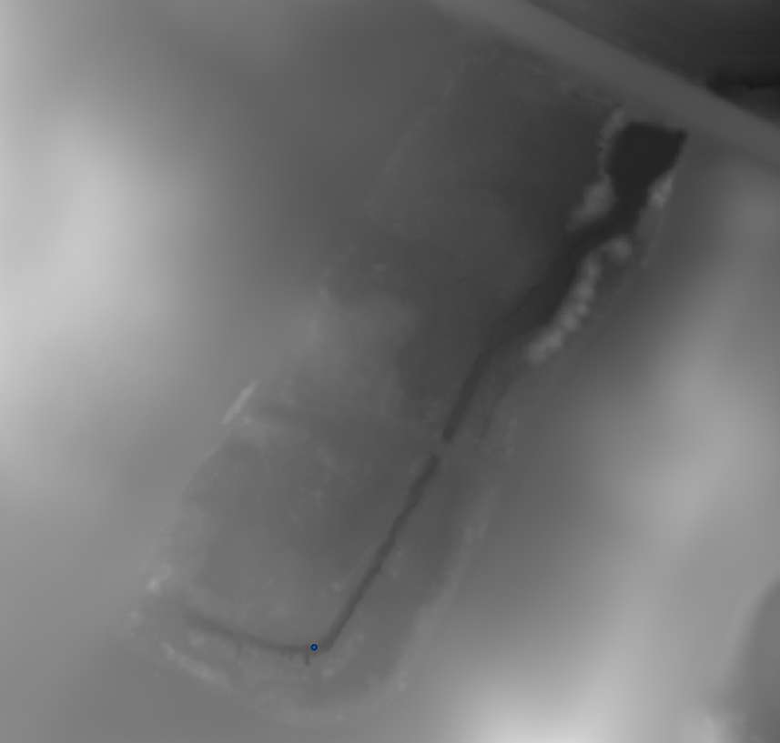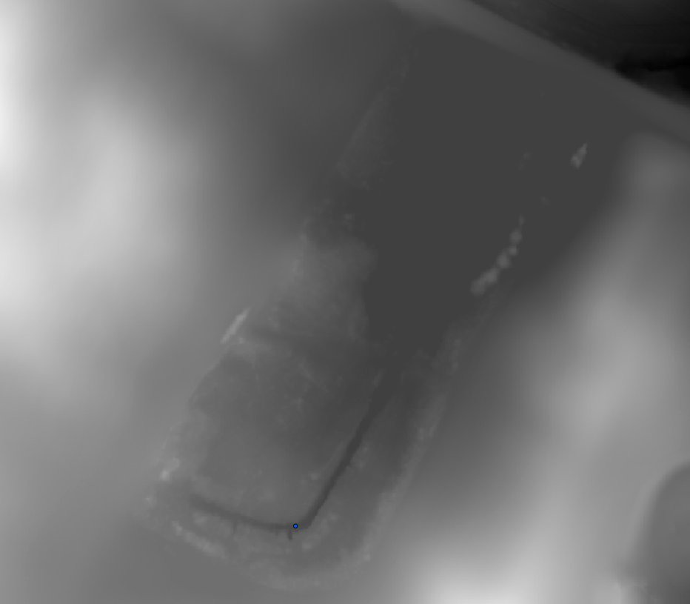
Study area 2:
MANY hidden culverts. Tried running the fill tool without noting these and it made it lag like crazy.
Reconditioning took awhile (2 minutes) but made fill tool move MUCH quicker.
Overall pretty solid results!
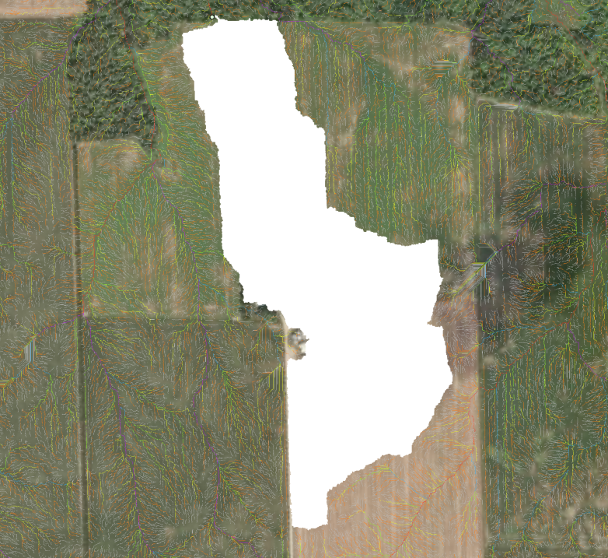

Using the web tool
Select whether you want to create only the stream network or the stream network + watershed and watershed statistics report
If you already have the location of your field’s outlet/pourpoint, you can generate the stream network and the watershed at the same time. If you do not have the location of your outlet, generate the stream network alone to place the outlet.
The study area is required for both options. If stream network only, you can disregard the outlet/pourpoint.
Stream network only
Use the pencil icon to create your study area.
Select cell size: 1m, 2m, 5m. Smaller cell sizes are higher resolution. They will produce more detailed results but will increase processing time.
Stream threshold: I’m just using a default value of 1000 since I’m not sure what it should be. Leaving it open for now but it could be hard coded and removed as a parameter later.
Click run. The tool should return a stream network. From this, you can determine the location of your outlet.
Watershed and stream net
Change the generation options to stream network and watershed and add the outlet/pour point. Hit run.
The tool will return the watershed, the longest streampath, and the stream network. The longest stream path appears underneath both other features; I don’t think there’s a way to fix this. Click and drag the longest stream path layer to the top to view it.
In the history tab, locate and click on the history item you just created from running the tool. This will open the history item details. In Result, find the HTML report. This block contains a hyperlink to a report with watershed statistics.

Maintaining the web tool

Uploading a geoprocessing (GP) tool to ArcGIS Enterprise
- Run the tool in ArcGIS Pro successfully. Runs with warnings should also work.
Make sure you are logged in with your Ontario geospatial portal (OGP) account and have it set as your active portal in ArcGIS Pro. You cannot share GP tools through the OMAFRA ontarioca11 portal.
- In the history tab, right click on the history item from the successful run of the tool
- Select the “Share As” dropdown menu, then either Share Web Tool or Overwrite Web Tool
- Set sharing to Owner and share with the Ag Erosion and Watershed Delineation Project group.
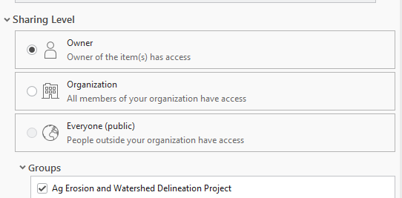
- Configure the tool: Check the Upload option under Capabilities and set the Execution Mode to Synchronous.
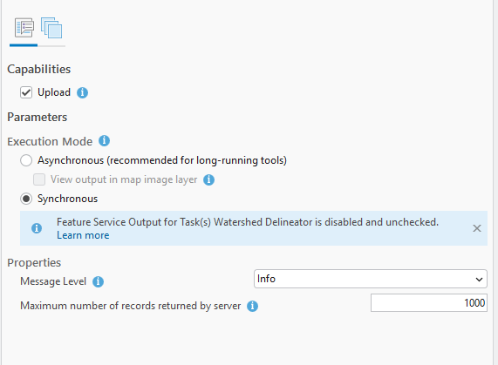
- Configure content: Content, open the Configure Tool Properties menu using the pencil icon.
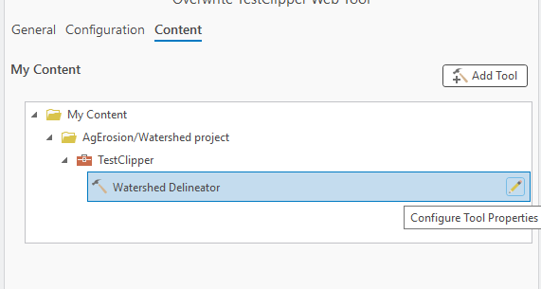
Remove the default values for the pour point and study area

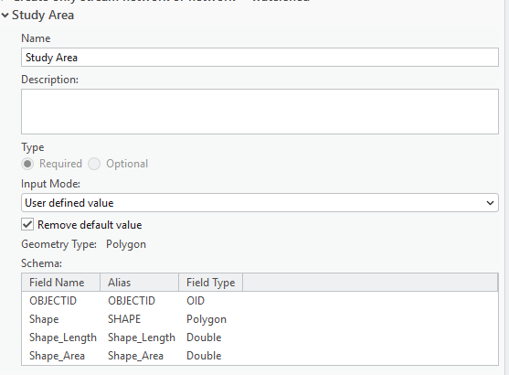
- Hit publish.

Adding the GP tool to experience builder
- Once the GP tool has been uploaded, open the Experience Builder project in edit mode and navigate to the Utility menu (wrench icon). The tool is not reliably refreshed, so I’ve found it’s easier to just delete the utility.
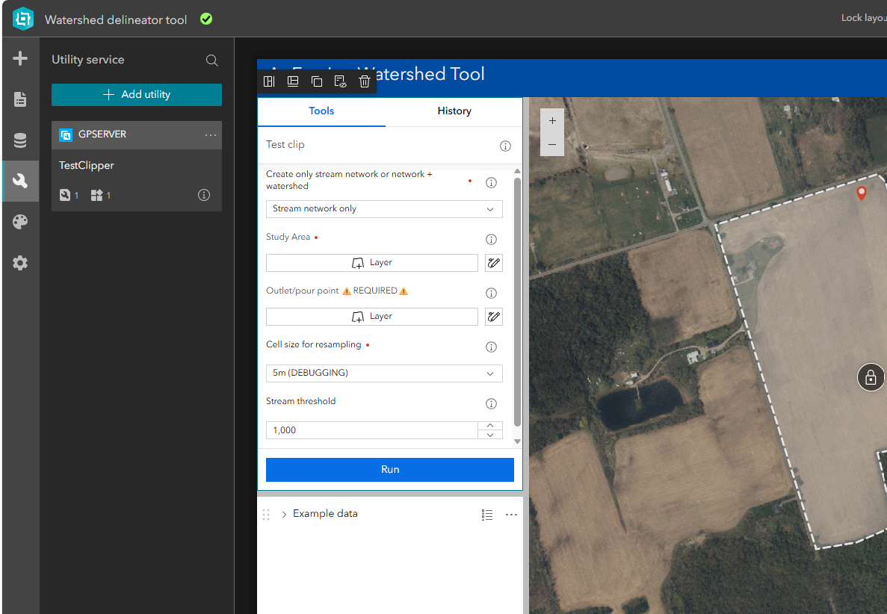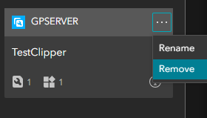

- Add the utility back from Items or grab the URL.
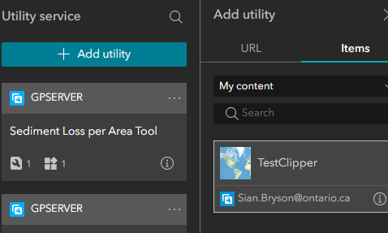
- Select the analysis widget. In the sidebar menu, select Custom web tool from the Add Tools list and select the tool you’d like to add.
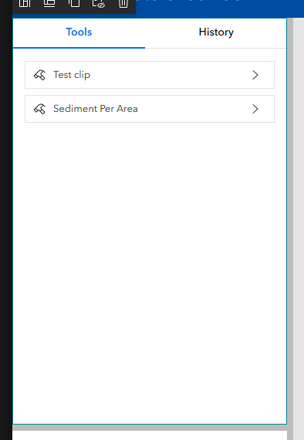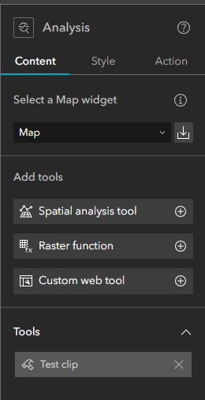
- I haven’t added any default symbology so you may need to change this for the stream network, longest path and watershed.
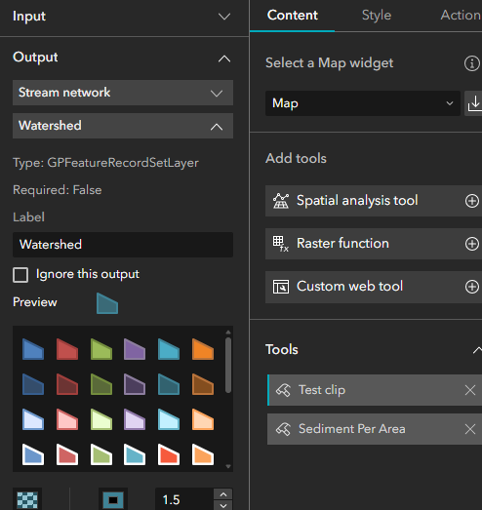
These are my usual choices:
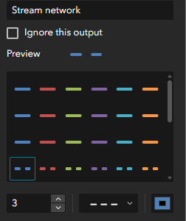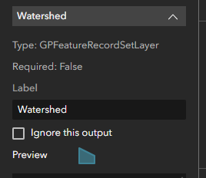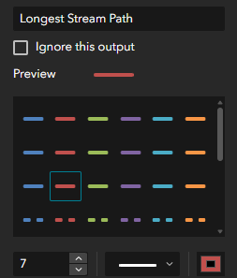

Desired improvements
- Ability to remove layers

